GRAMMY NOMINEES GENTLE THUNDER & CRAIG CHAQUICO TO PERFORM IN MIAMI
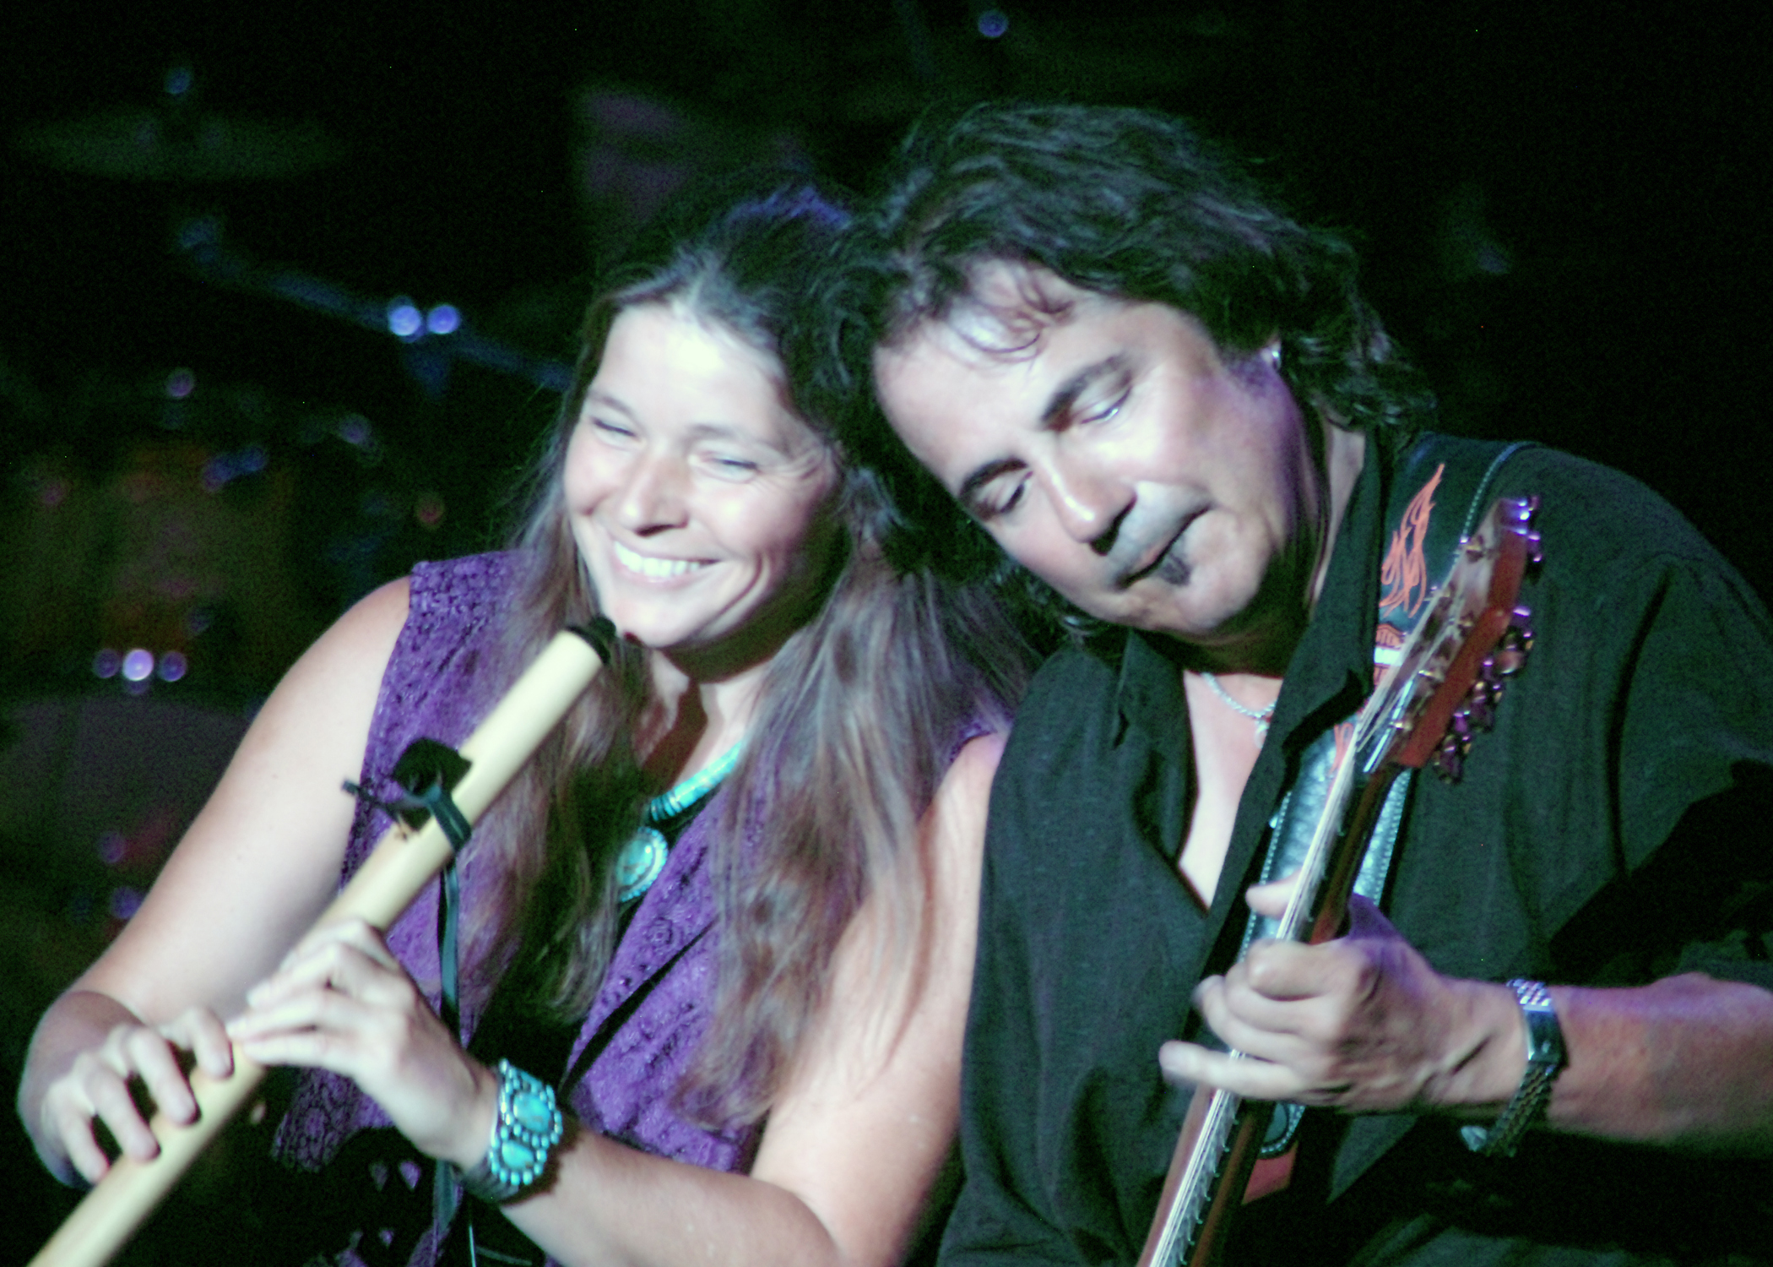
Miami, FL – Dream Provider and Natural Awakening Magazine presents 2006 GRAMMY® nominated multi-instrumentalist, recording artist, composer and producer, Gentle Thunder with very special guest cameo appearance by GRAMMY® nominated, multi-platinum recording artist, composer, producer and former guitarist of Jefferson Starship/Starship, Craig Chaquico November 15, 2008 at 8 PM for an Intimate Evening of Music at the Miami Science Museum Theater. Gentle Thunder will offer her GRAMMY® nominated spirit infused musical magic on grand hammer dulcimer and several Native American flutes for the first time in Miami, FL. This internationally acclaimed artist is known for her distinctive sound and heart filled presence. In a rare solo cameo appearance as a special guest artist, multi-platinum recording artist and former guitarist of Jefferson Starship/Starship, Craig Chaquico, will weave into the evening with Gentle Thunder sharing some of his #1 GRAMMY® nominated smooth jazz and contemporary instrumental hits accompanied by Gentle Thunder. The concert is a special presentation hosted by the Miami Science Museum in conjunction with their MUSICA Exhibit running 10/25/08 thru 2/22/09 (3280 S. Miami Ave, Miami, FL 33129) www.miamisci.org and Gentle Thunder will offer a workshop on November 14, 2008 2-4 pm for $30. A portion of the proceeds will benefit non-profits Rising International and Pridelines Youth Services. Concert tickets are general seating $40 advance / $50 door. Purchase all tickets online: www.BrownPaperTickets.com or 24 hr charge by phone: 800-838-3006. More Info: (786) 419-3165 www.GentleThunder.com ~ www.CraigChaquico.com

Gentle Thunder hails from Mt. Shasta, CA yet enchants audiences worldwide with her distinctive sound and heart filled presence. Beyond Words, her third release (a trio album with Will Clipman & AmoChip Dabney) was GRAMMY® nominated Best New Age Album in 2006. Her most recent solo release, Opening the Gate reached #13 in New Age Reporter Top 100 and was nominated Best Native American album in the 2007 NAR Lifestyle Music Awards. The Wall Street Journal’s Jim Fusilli calls her music “direct and organic”. Gentle Thunder made her first cameo appearance on Native American flute with Craig Chaquico at the Britt Festival in Jacksonville, OR in July 2007 that initiated her joining his band on several dates around the country this past year whenever her recording and tour schedule allowed. This upcoming concert will be an up close and personal opportunity to experience these two solo artists weaving together in an intimate venue.

After four decades at the top of the charts ('70s, '80s, 90s, '00s) Craig started as band member, lead guitarist, principal songwriter, co-producer, and arranger with the legendary multi-platinum Jefferson Starship/Starship (1973-1990). Chaquico was instrumental in making the Jefferson Airplane & Jefferson Starship/Starship combination among the TOP 10 most successful acts in history, receiving 20 gold records. According to the RIAA this prestigious position is shared only with Elvis Presley, Barbra Streisand, The Rolling Stones, Neil Diamond, The Beatles, Frank Sinatra, Elton John, and Bob Dylan among others. In the ‘90s and the ‘00s Chaquico then transformed into an award-winning solo smooth jazz artist and producer selling more than a million copies on his own. He was #1 on the Billboard Charts, Guitar Player Magazines’ Readers Poll #1 Best Pop Instrumental Guitarist and Jazz Is magazine included him in the top 100 most influential jazz guitar players of all time. Making a cameo appearance during the evening he will share hits from his #1 solo smooth jazz records, highlighting his awe inspiring skill with a guitar, while incorporating a little musical magic from multi-instrumentalist Gentle Thunder in this up close and personal intimate evening of music in Miami.
####
Photo of Gentle Thunder & Craig Chaquico by Lani Phillips

